**Get to know Europe with 3Seaseurope**

**Do you want to travel around Europe with us? If so, you should absolutely visit the official 3SeasEurope website. This is a webpage built on the initiative of 3 Seas that strives to deliver the most up-to-date information on this region of Europe.**

Central Europe is a fascinating location with many previously discovered stories worth sharing. **3SeaEurope** was built specifically for this aim - to communicate them to the rest of the globe while emphasizing the region's distinctive customs, landmarks, achievements, and possibilities.

**3SeaEurope will let you discover Europe!**

There are several negative perceptions about Central and Eastern Europe that should be dispelled. The nations located between the Baltic, Adriatic, and Black Seas have a very rich identity that is well worth learning about. That's why the official [3SeasEurope](https://3seaseurope.com) website is worth a look, as it deals with the twelve countries on the European Union's eastern flank that participate in the Three Seas Initiative - a platform aimed at improving connections between EU member states located between the Baltic, Adriatic, and Black Seas. Austria, Bulgaria, Croatia, the Czech Republic, Estonia, Hungary, Latvia, Lithuania, Poland, Slovakia, and Romania are among them.

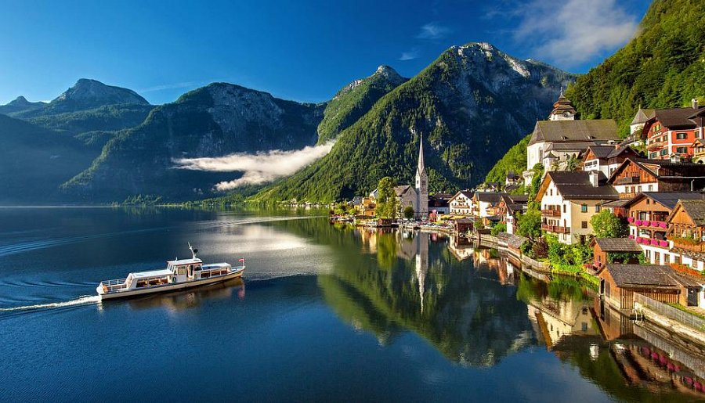

**Europe is an enthralling place.**

There is no disputing that Europe has a lot to see and explore. By perusing the site, you may discover new locations to explore, new foods to taste, and intriguing tales about individuals from all of the region's nations. *3SeasEurope* will provide you with a wealth of knowledge; it is up to you to discover it. We welcome you to browse our website!